Image | 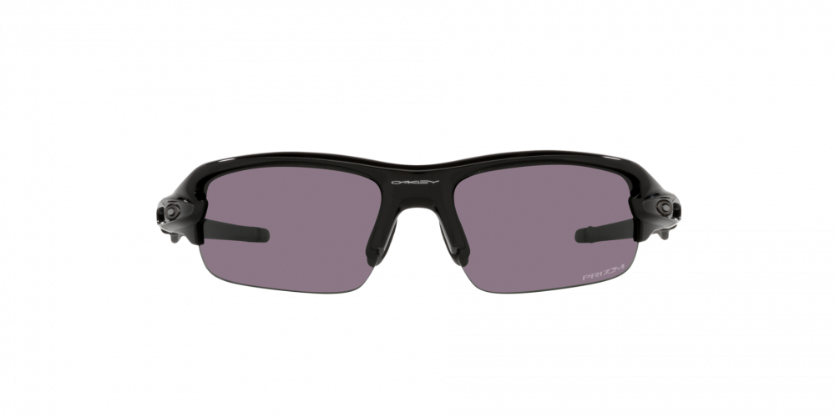
Brand | OAKLEY
Model Name | FLAK® XXS POLISHED BLACK
Price | RS 2999
PRODUCT DETAILS

